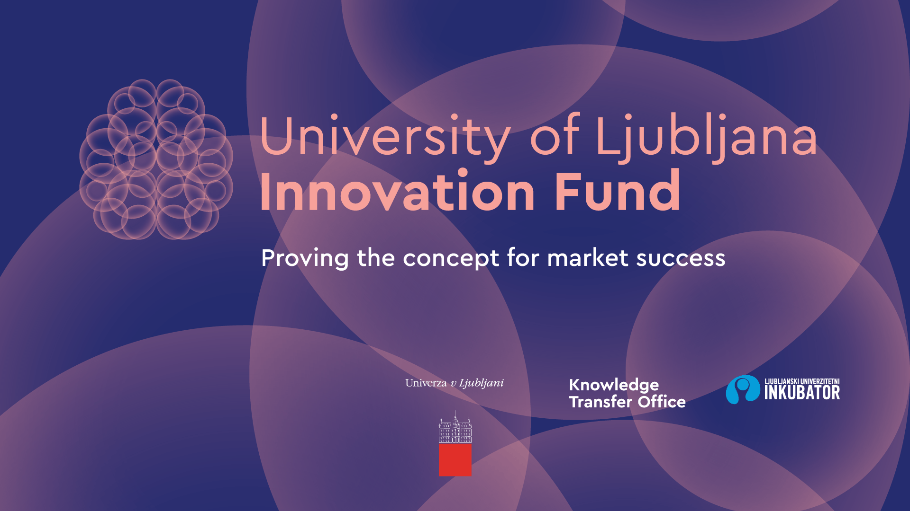
University of Ljubljana Innovation Fund Call for proposals
Application form for the Innovation Fund Call for proposals
Please send the completed, signed and scanned application form via email to:
gospodarstvo@uni-lj.si

You can remove the text marked grey. Please adapt/complete the text marked yellow.

Project title

[Enter project title]

Information about the applicant and project manager

Applicant – member: | [title of the UL member]
Project manager’s name and surname | [name and surname]
Project manager’s laboratory/department | [title of the laboratory/department]
Project manager’s job title | [employment position]
Project manager’s e-mail address | [e-mail address]
Project manager’s mobile telephone number | [mobile tel. number]

We hereby confirm that all the data on the application form are accurate and that the inventors/authors employed at the UL also agree with the conditions of the Call.

Place and date

Project manager’s signature Dean’s signature
Signature: __________________________ _____________________

SUMMARY OF PROJECT PROPOSAL

[Please provide a brief summary. It should be concise and understandable! Focus on the essence of the message. The Evaluation Team member reading your summary should clearly understand what you do, what problem you are solving, what are the objectives of the proposed project and how you intend to measure success.]

BASIC CONDITIONS OF THE CALL FOR PROPOSALS

  - The technology, that is the subject of the project application, is owned by the University of Ljubljana. If there are several owners, the technology is at least 50% owned by the University of Ljubljana (if there are two owners) or at least 30% owned by the University of Ljubljana (if there are three or more owners).
- YES
- NO

  - If the technology is co-owned by another public research organisation, it has provided the STATEMENT on the acceptance of the conditions of the Call:
- YES
- NO

  - Technology readiness level (TRL): ___

  - The project manager/inventor is employed at least half-time at the University of Ljubljana.

- YES
- NO

  - A license contract/assignment agreement of intellectual property rights of the applied project has not been concluded yet, nor has a spin-out company been established.
- YES
- NO
- It is in the process of being signed/established.

1.TEAM

Please list the project’s team members (inventors/authors of the solution) and their respective research fields. Add brief CVs and highlight collaboration with the business sector/realisation of applied projects!

Team members’ names and surnames # | Title of the UL member - laboratory | Expert fields of research
- [title + name + surname] | [title of the UL member, laboratory] | [research fields]
Brief CV of a team member – highlight collaboration with the business sector
- [title + name + surname] | [title of the UL member, laboratory] | [research fields]
Brief CV of a team member – highlight collaboration with the business sector
- [title + name + surname] | [title of the UL member, laboratory] | [research fields]
Brief CV of a team member – highlight collaboration with the business sector
- [title + name + surname] | [title of the UL member, laboratory] | [research fields]
Brief CV of a team member – highlight collaboration with the business sector
…

PROJECT ORIGINALITY, INNOVATIVENESS

2.1 Describe the problem the project addresses and who is facing the problem.
Please describe what type of a problem the project addresses and who is facing it, along with the baseline state of the problem.

2.2 Describe your solution.
Please describe your technological solution – how does it solve the identified problem?
A brief video presentation (up to 3 minutes) describing the problem and your proposed solution is desirable.
Please enter the URL via which the brief video presentation can be accessed.

2.3. What are the advantages of the proposed project compared to the competitive solutions (name the competitors to your project)?
Please describe how your project solves the highlighted problem and what key features/functions of the product/service/solution have been improved.

2.4 What are the existing solutions and patents?
Please describe specific examples of the state-of-the-art/services/procedures/ideas/methods, compare the proposed project with the existing situation, provide a review of the patents and other protections of intellectual property and a review of the scientific and expert literature
.
2.5. In what way is the intellectual property, related to this project, legally protected?
Encircle the type of intellectual property right by which your solution is protected:
- a patent
- patent application
- industrial design
- industrial design application
- trademark
- trademark application
- copyright
- trade secret
- The intellectual property cannot be protected.
- other
2.6 Has the project been entered for the Rector's Award for the best innovation at the University of Ljubljana or another comparable competition?
Please select and, if necessary, elaborate the statement corresponding to your project:
- YES
  - ____ If yes, please state the competition, the year of competing and the achieved result
- NO

3. MARKET POTENTIAL

3.1 Target groups of clients or end users.
Please define the target groups of clients or end users.
3.2 Market size
Please select the statement corresponding to your project:

Size of the project’s market potential:
- The market is local.
- The market is global – niche market potential.
- The market is global – general market potential.

Please describe the market size in a clear and specific way (volume, state, market channels).

3.3. Planned entry to the market
Please describe the planned possibilities of entering the market in a clear and specific way. How would you enter the market? Who, i.e. what companies, would you enter it with? Are you well connected with them? Why now?

3.4 Coinciding of the project with trends
Please select and elaborate the statement corresponding to your project:

- The proposed project coincides with the current trends (follows the trends): _________________.
- The proposed project is a trendsetter, a leading creator of trends: _________________.
3.5 Exposure to competition
Please select and elaborate the statement corresponding to your project:

• The proposed solution is highly exposed to competition, its competitive advantages are imperceptible: _________________.
• The proposed solution is slightly exposed to competition, its competitive advantages are great: _________________.
3.6 Spin-out company
Please select and elaborate the statement corresponding to your project:

- The applicant – researchers are considering establishing a spin-out company:
  - YES
  - If YES, please define in what time period they would like to establish the company.
  - NO

4.1. PROJECT ACTIVITIES
4.1 Planned activities and timeline
Seq. No. | Description of activity | Duration of activity  (beginning – end) | Estimated cost of activity, by types of cost | Expected results
1 | [] | Start month No.# End month No.# | Labour costs: []  External costs: []  Equipment costs: []  Attendance at an industry fair: [] | []
2 | [] | Start month No.# End month No.# | Labour costs: []  External costs: []  Equipment costs: []  Attendance at an industry fair: [] | []
3 | [] | Start month No.# End month No.# | Labour costs: []  External costs: []  Equipment costs: []  Attendance at an industry fair: [] | []
… | [] | [] | [] | []

4.2 Potential risks

[Please define potential risks (technical, software related, market or other risks). How high/low are these risks? Please define how you can mitigate them. Propose a method of monitoring the complete project activities and ensuring efficient usage of the funds received.]

4.3.RAISING THE TECHNOLOGY READINESS LEVEL

[Please define how/by how much the commercialisation possibilities will increase after the project has been implemented. Define whether the project is feasible within the time period given.]

FINANCIAL PLAN

Financial plan
Eligible costs | Cost description | A:  Innovation Fund cost (€) | B:  Funds from other sources, including companies (€) | S.  Total costs  (€)
Labour costs for a new/additional employee (up to 20% of all costs). | Name and surname, role in the project | cost in € | cost in € | €
Material costs | [] | € | € | €
External costs | [] | € | € | €
Equipment (up to 30% of all costs). | [] | € | € | €
Attendance at industry fairs, visiting potential industry partners abroad | [] | € | € | €
TOTAL COSTS |  | € | € | €

Please add a list of letters of support or intents for collaboration. Please enclose the letters/intents as additional documentation.
Letter/Intent # | Company/organisation | Signatory | Date
1 | [] | [] | []
2 | [] | [] | []
…
Letters of support/Intents for collaboration by organisations/companies not directly involved in the project, but supporting the project or its objectives. The letter/intent shall:

- Be provided on an official letterhead of the organisation/company, signed by the legal or authorized representative of the organization/company (the signatory’s function shall also be provided).
- The letter/intent should not be older than 3 months.
- It must include a detailed interest in the project, type of involvement in the project in view of the special objectives (of the company/organisation) and the desired results for the organization/company’s business.
- It must also include a description of how the organisation/company could commercialise the technology that is the subject of the project.

Please enclose the legal basis for collaboration with companies (e.g. contract on joint development).

